Two-Column Template for Proceedings

A.B. Firstauthor* and D.E. Secondcoauthor*
*Department, University, Country
e-mail: e-mail address of the first (and presenting) author

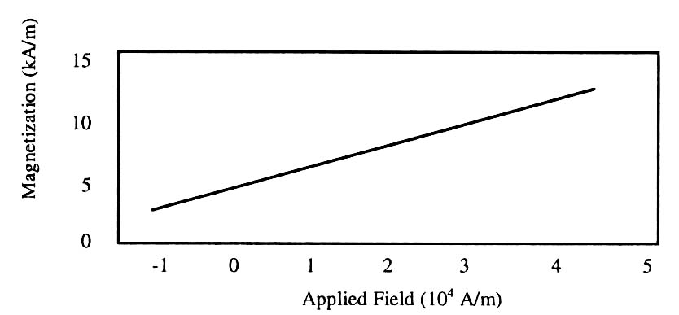
- Magnetization as a function of applied field. Note how the caption is centered in the column

Introduction
Please use this as a template to prepare an extended abstract for submission to Aug. 5th UK-Japan Workshop and Aug. 8th MISW-2016 joint session for publication in the proceedings which will be distributed at Tokyo Tech. Note the abstract will be printed in monochrome or gray-scale, please do not use color in your abtract figures. All presentations will be posters.

Abstract Deadline: 30th June, 2016
File type: Save as PDF file
File name: UK-Japan_Surname-Firstname. PDF
Send your abstract to: ukj2016@spin.ee.e.titech.ac.jp

Full-Sized Camera-Ready (CR) Copy
Prepare your CR paper in full-size format, on A4 paper (210 x 297 mm).
Type sizes and typefaces: Follow the type sizes specified in Table I. Times New Roman is the preferred font.
Margins: top & bottom = 25mm, left & right = 20 mm.
The column width is 82mm (3.23 in). The space between the two columns is 6mm (0.24 in). Paragraph indentation is 3.5 mm (0.14 in).
Left- and right-justify your columns. Use tables and figures to adjust column length.
- Type Sizes for Camera-Ready Papers
Type size (pts) | Regular | Italic
8 | Section titles,* captions, references, tables*, first letters in table captions,* figure captions, text subscripts, and superscripts
10 | Authors’ affiliations, main text, equations, first letters in section titles* | Subheading
24 | Paper title

* Uppercase

Pages
You are allowed only one page for your extended abstract.

Helpful Hints

Figures and Tables
Figure captions should be centered below the figures; table captions should be centered above. Put units in parentheses on the figure axis labels. Please prepare your figures with consideration they will be reproduced in the black & white proceedings. Color figures will not reproduce well in black & white. Please use shades of gray, line thickness or dashes to compare data in line graphs. Figure label fonts should be > 10-point type.

Equations
Number equations consecutively with equation numbers in parentheses flush with the right margin, as in (1). Italicize Roman symbols for quantities and variables, but not Greek symbols. Use parentheses to avoid ambiguities in denominators. Punctuate equations with commas or periods when they are part of a sentence, as in
$a + b = c$. (1)

References
Number citations consecutively in square brackets [1]. Punctuation follows the bracket [2]. Refer simply to the reference number, as in [3].
List all author names. In a paper title, capitalize the first word and all other words except for conjunctions, prepositions less than seven letters.

References
- T. Koudai, O. Okayama, Proceedings of Multidisciplinary International Student Workshop, p. 1881, May 2014.
[2] K. Suzukake, J. Kougaku, Transactions of Journal of Engineering, 5, 100, 2016.

